**PROJECT DEVELOPMENT PHASE**

**SPRINT-1**

|  |  |
| --- | --- |
| Date | 17 November 2022 |
| Team ID | PNT2022TMID08185 |
| Project Name | Project-  "Exploratory Analysis Of Rainfall Data In India For Agriculture" |
| Tasks | Login and Register |

•

**LOGIN PAGE**

**:**

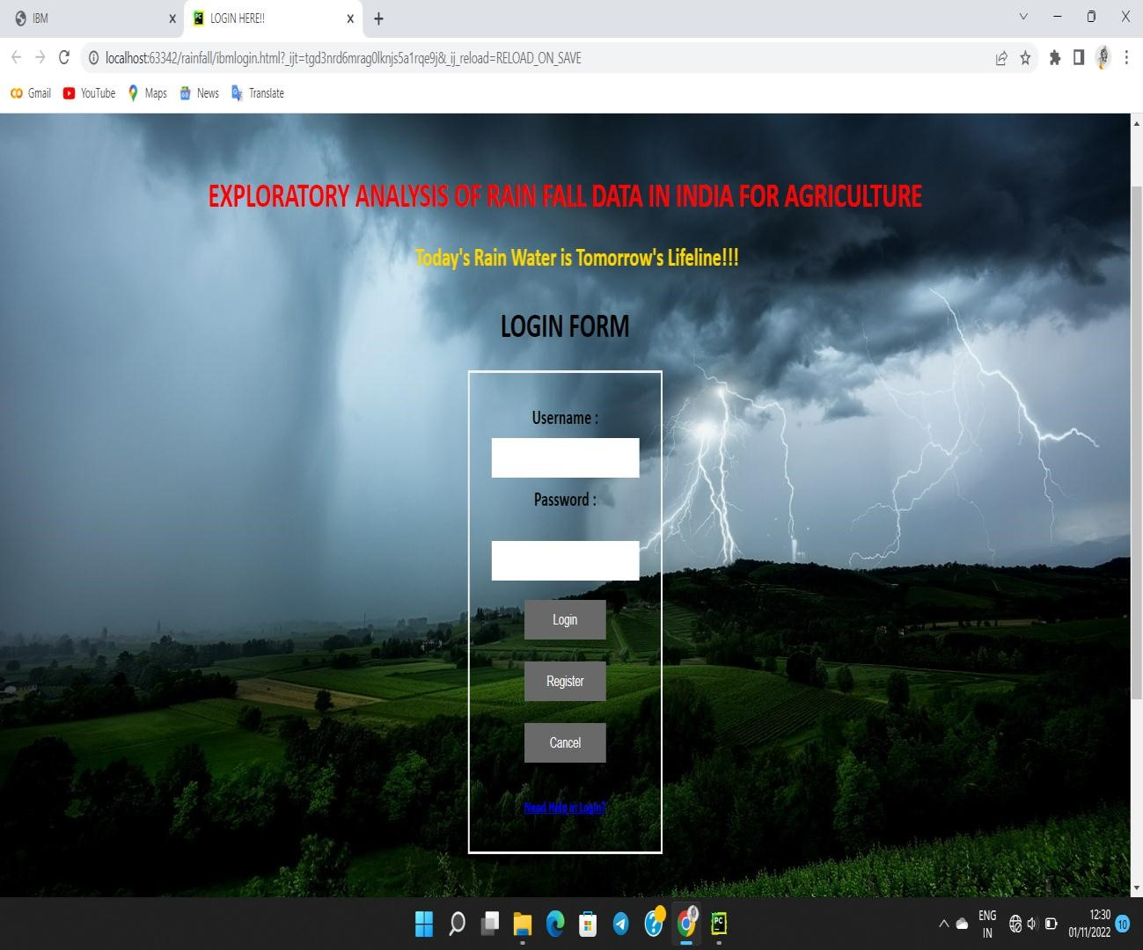

• **REGISTER PAGE:**

